[Include the woodcut of Long Yocto at the start.]

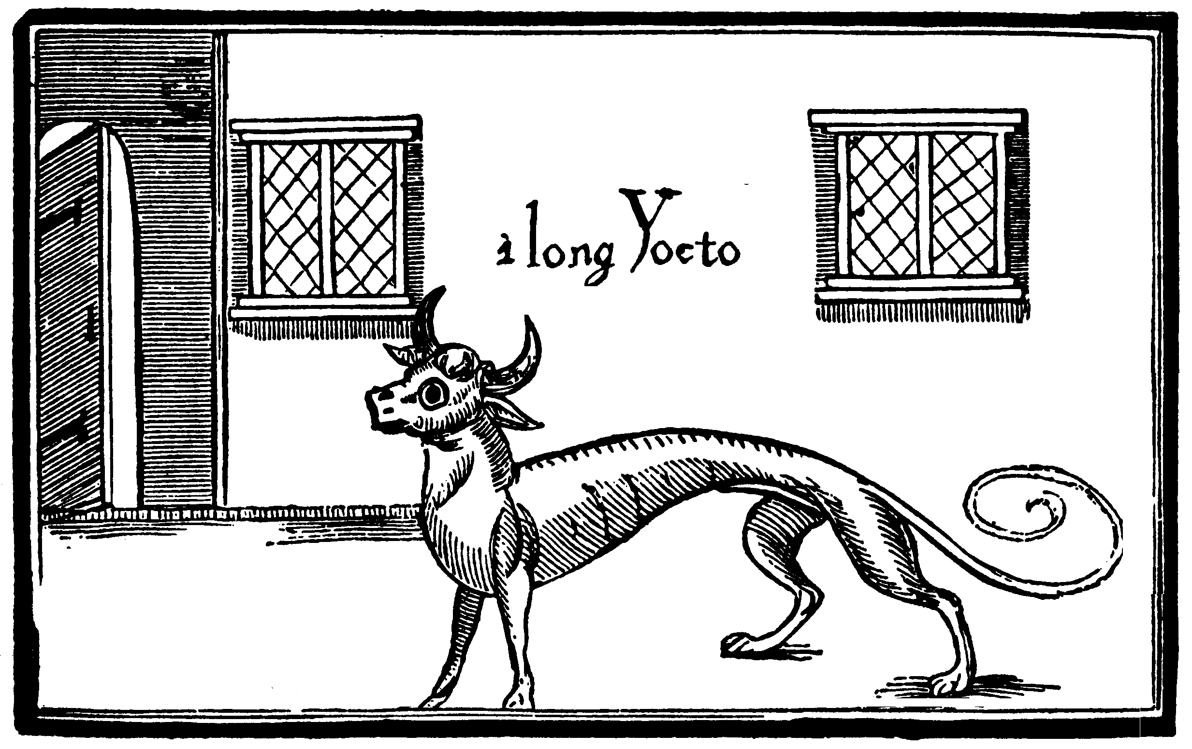

Narrative Introduction
Anne & Yocto’s story (with quotes) in a paragraph, begun in media res.

“a strange, co-dependent relationship”
“In 1759, as far as I’m concerned.”
“a fragmentary grimoire, a 'holy manual'”
“an age when the autocosmic world of a superstitious public were giving way to the rationalism of the Enlightenment.”

Project Introduction
- The technologies used and the experience designed.
- Ways that you might get to play it, if you are not an examiner.
- Why it is called knole; no reason.

